HE3001 Tutorial 3 Solutions
1. Considering the following sequential game. Player 1 chooses either action A or action B. Player 2, after observing Player 1’s action, chooses either action a or action b. The payoff matrix for combinations of actions are as follows:
Player 2

 | a | b
A  Player 1 | 0,2 | 3,3
B | 4,5 | -1,3

- Represent the game in extensive form, highlighting all the subgames.
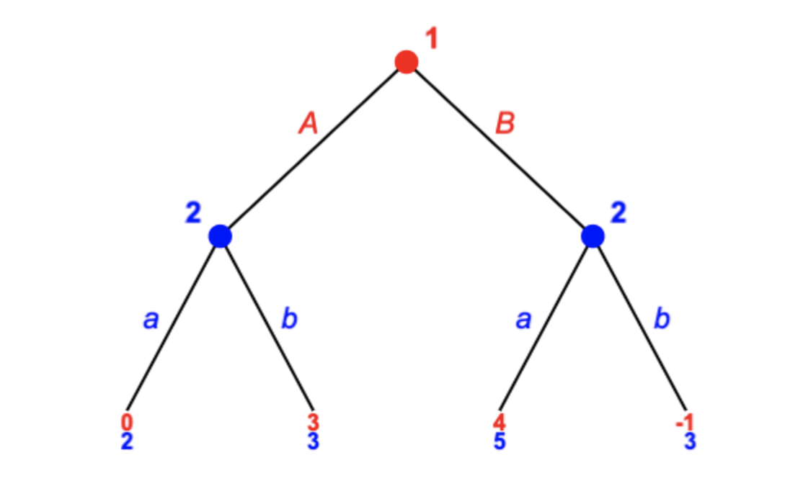

- What is the normal form representation of the game?
Recall that the strategy of Player 2 is to choose a pair of strategies, one for each of the observed action of Player 1. Let (x,y) denote that Player 2 chooses x if Player 1 chose A and Player 2 chooses y if Player 1 chose B.
Player 2
 | (a,a) | (a,b) | (b,a) | (b,b)
A  Player 1 | 0,2 | 0,2 | 3,3 | 3,3
B | 4,5 | -1,3 | 4,5 | -1,3

(c) Find the Subgame Perfect equilibrium strategies and state the SPNE outcome.
By backward induction, starting at the last subgames, Player 2’s best response is (b,a).
Given Player 2’s strategy, the best response of Player 1 is to choose B.
The SPNE strategies thus are
- Player 1 chooses B
- Player 2 chooses b if Player 1 chooses A, Player 2 chooses a if Player 1 chooses B.
The SPNE outcome is Player 1 chooses B, and Player 2 chooses a, with a payoff of (4,5)
2. Two software companies sell competing products which are substitutes, resulting in sales being influenced by each product’s price. Let $p_{1}$ be the price and $x_{1}$ the quantity sold of product 1, and $p_{2}$ and $x_{2}$ for product 2. Then $x_{1}=1000(90-\frac{1}{2}p_{1}+\frac{1}{4}p_{2})$ and $x_{2}=1000(90-\frac{1}{2}p_{2}+\frac{1}{4}p_{1})$. Each company has incurred a fixed cost, but the cost of selling to an extra user is zero. Therefore, each company will maximize its profits by choosing the price that maximizes its total revenue.
(a) Write an expression for the total revenue of company 1, as a function of its price $p_{1}$ and the other company’s price $p_{2}$.
$${Revenue}_{1}={p_{1}x}_{1}=1000(90p_{1}-\frac{1}{2}{p_{1}}^{2}+\frac{1}{4}p_{1}p_{2})$$

(b) Company 1’s best response function ${BR}_{1}(p_{2})$ is defined as the price for product 1 that maximizes company 1’s revenue given that the price of product 2 is $p_{2}$. Write down ${BR}_{1}(p_{2})$.
Take the derivative of revenue with respect to $p_{1}$ and solve for the revenue-maximizing $p_{1}$ given $p_{2}$.
$$1000\left(90-p_{1}+\frac{1}{4}p_{2}\right)=0$$
$$p_{1}=90+\frac{1}{4}p_{2}$$
$${BR}_{1}\left(p_{2}\right)=90+\frac{1}{4}p_{2}$$

(c) Use a similar method to solve for company 2’s best response function $BR_{2}(p_{1})$.
$${BR}_{2}\left(p_{1}\right)=90+\frac{1}{4}p_{1}$$

(d) Solve for the Nash equilibrium prices.
The Nash equilibrium is the intersection of the companies’ best response functions:
$$\begin{aligned}p_{1}=90+\frac{1}{4}p_{2} \\ p_{2}=90+\frac{1}{4}p_{1}\end{aligned}$$
Solving this gives:
$$p_{1}=120, p_{2}=120$$

Let us try to solve for the subgame perfect nash equilibrium when companies move sequentially.
(e) Suppose that company 1 sets its price first. Company 2 knows the price $p_{1}$ that company 1 has chosen and it knows that company 1 will not change this price. If company 2 sets its price so as to maximize its revenue given that company 1’s price is $p_{1}$, then what price will company 2 choose?
This is just the same as before:
$${BR}_{2}\left(p_{1}\right)=90+\frac{1}{4}p_{1}$$
This function describes the Nash Equilibrium in any subgame for any price chosen by company 1.

(f) If company 1 is aware of how company 2 will react to its own choice of price, what price will company 1 choose?
Since company 1 takes into account company 2’s strategy, we substitute ${p_{2}=BR}_{2}\left(p_{1}\right)$ into the revenue function.
$${Revenue}_{1}={p_{1}x}_{1}=1000(90p_{1}-\frac{1}{2}{p_{1}}^{2}+\frac{1}{4}p_{1}p_{2})$$
Substituting $p_{2}=90+\frac{1}{4}p_{1}$, then ${Revenue}_{1}=1000(90p_{1}-\frac{1}{2}{p_{1}}^{2}+\frac{45}{2}p_{1}+\frac{1}{16}{p_{1}}^{2})$
Take a derivative of revenue with respect to $p_{1}$ and solve for the revenue-maximizing $p_{1}$.
$$p_{1}=900/7$$
This completes the NE in the overall subgame.

The SPNE strategies are as follows:
Company 1 chooses $\frac{900}{7}$
Company 2 chooses a price $90+\frac{1}{4}p_{1}$ for any price $p_{1}$ observed to be chosen by Company 1.

The SPNE outcome is:
Company 1 chooses $\frac{900}{7}$
Company 2 chooses $90+\frac{900}{28}$

3. Let us look at the “compound” game which Victoria and Albert play from last week’s tutorial.
(In lecture 3, this was one of the examples of “hybrid sequential games”.)
Recall that they play Game A (in Week 1) before Game B (in week 2), each of which is played simultaneously in their respective weeks. Both observe perfectly the outcome in Game A, before Game B is played.
Game A
Victoria
 | Clean | Don’t Clean
Clean  Albert | 5,5 | 2,6
Don’t Clean | 6,2 | 3,3

Victoria
Game B
 | BBQ | Macs
BBQ  Albert | 5,5 | 2,1
Macs | 1,2 | 3,3

(a) In the extensive form of the compound game, highlight all the subgames.
Game A
Game B
Game B
Game B
Game B
Clean, Clean
Clean, No Clean
No Clean, Clean
No Clean, No Clean

Since game B is played after game A, they can condition their action in game B on what happens in game A.
Consider the following strategies (for both players):
- If outcome in game A in Week 1 is (Clean, Clean), choose Korean BBQ in game B in Week 2.
- If outcome in game A in Week 1 is not (Clean, Clean), choose Macs in game B in Week 2.

(b) Do the strategies specified above for game B consist of a Nash equilibrium in each of the possible histories of Game A?
Yes. (BBQ, BBQ) and (Macs, Macs) are Nash equilibria of the static stage game. Hence, they are also Nash equilibria when played as part of these two games played in sequence.
Suppose the outcome was (Clean, Clean), the strategy would for each of them be to play BBQ in game B. Given that the other is going to be playing BBQ in game B, one will not want to deviate from playing BBQ as well.
Suppose the outcome was not (Clean, Clean), the strategy would for each of them be to play Macs in game B. Given that the other is going to be playing Macs in game B, one will not want to deviate from playing Macs as well.

(c) Given the strategies for game B, verify that choosing to clean is the best response if the other is cleaning as well. Assume that their total payoffs are just the sum of their payoffs in Games A and B.
Given their strategies for game B, conditional on outcomes in game A:
If Albert chooses to clean, given that Victoria chooses to clean, his payoff is 5 (from C,C) + 5 (from BBQ,BBQ). If Albert chooses instead not to clean, he gets 6 (from DC,C) + 3 (from Macs, Macs), which is lower. The same follows for Victoria’s choice to clean.
Hence, it is a best response for both of them to choose to clean in game A during week 1 given that the other is cleaning and the strategies in game B.

(d) Do you think that the following strategies form a subgame perfect Nash equilibrium of the sequential game here?
For both players:
In Week 1: Choose to Clean.
In Week 2:
If outcome in game A is (Clean, Clean), choose Korean BBQ in game B.
If outcome in game A is not (Clean, Clean), choose Macs in game B.
Yes.
There are 5 subgames.
4 of the subgames occur after each possible history of game A.
In each of these subgames, which is just game B, the specified strategies are a Nash equilibrium, as shown in part (b).
In the last (overall subgame), the strategies chosen for game A in week 1 are best responses to the other’s overall strategy and hence form a Nash Equilibrium of the overall subgame as well, as shown in part (c).
Thus, all their strategies form a NE in all the subgames; hence we have a SPNE here.

Notice that what allows for this is the multiplicity of NE in game B, compared to if game A were repeated twice. Similarly, if a game is repeated finitely many times, but there are multiple NE in the game, then it is possible for other outcomes to occur in earlier stages.
(This is related to backward induction for sequential games. To get a SPNE, we first need to specify outcomes which are best responses and hence NE in each of the 4 Game Bs. Then, given the outcomes in each of these 4 game Bs, players have to choose their best response in Game A. The full set of strategies for game A and all the game Bs will then be a SPNE.)

Extra: Note also that this subgame perfect NE is not unique as given the multiple NE in game B, we can select different NE for each of the 4 histories --- this will lead to different best responses in game A.
For example the following strategies are an example of a subgame perfect NE where they do not Clean in week 1.
For both players:
In Week 1: Choose not to Clean.
In Week 2: No matter what is the outcome in game A, choose Macs in game B.

4. Consider the following game where Player 1 first chooses between a coordination game and a prisoner’s dilemma game as shown below. After that, Player 1 and 2 play the chosen game simultaneously.
Player 2
Coordination Game
 | Heads | Tails
Heads  Player 1 | 4,4 | 0,0
Tails | 0,0 | 2,2

Player 2
Prisoner’s Dilemma Game
 | Cooperate | Defect
Cooperate  Player 1 | 6,6 | 2,8
Defect | 8,2 | 3,3

- Represent the game in extensive form, highlighting all the subgames.
See example in lecture notes. There are 3 subgames: each of the simultaneous games and the overall game.

- Give an example of a SPNE where the SPNE outcome is for Player 1 to choose the Coordination game.
Let the strategies be:
(H,H) in the coordination game, (D,D) in the PD game, and Player 1 chooses the coordination game.
(H,H) is a NE in the coordination subgame. (D,D) is the unique NE in the PD subgame. (You can show this by solving the simultaneous games as per normal)
Given the results in the subgames, the best response of Player 1 is to choose the coordination subgame since he will get 4 from the coordination game instead of 3 from the PD game.

- Give an example of a SPNE where the SPNE outcome is for Player 1 to choose the Prisoner’s Dilemma game.
Let the strategies be:
(T,T) in the coordination game, (D,D) in the PD game, and Player 1 chooses the prisoner’s dilemma game.
(T,T) is a NE in the coordination subgame. (D,D) is the unique NE in the PD subgame. (You can show this by solving the simultaneous games as per normal)
Given the results in the subgames, the best response of Player 1 is to choose the PD subgame since he will get 3 from the PD game instead of 2 from the coordination game.

Extra: Note that the SPNE do not necessarily have to be in pure strategies. For example, in the coordination game, there is also a mixed strategy NE: Player 1 plays heads with probability 1/3, Player 2 plays heads with probability 1/3 which has an expected payoff of $4/3$.
If these are their strategies for the coordination game, then Player 1 will choose the prisoner’s dilemma game since it gives a higher payoff of 3.
Another SPNE is hence:
(H: 1/3, H: 1/3) in the coordination game, (D,D) in the PD game, and Player 1 chooses the prisoner’s dilemma game.

